**Assignment 2:**

**Implement Constraint Satisfaction Problem (CSP)**

**Problem Statement:**

The goal of this assignment is to solve a constraint satisfaction problem (CSP) like Sudoku using backtracking. You will learn to represent the problem, define its constraints, and implement an algorithm to find a valid solution.

**Objectives:**

* Learn to represent and solve CSPs.
* Implement backtracking to find solutions effectively.

**Theory**

**What is a CSP?**

A CSP consists of:

* **Variables**: Elements that need to be assigned values (e.g., cells in Sudoku).
* **Domains**: The set of possible values each variable can take (e.g., numbers 1-9 for Sudoku).
* **Constraints**: Rules that dictate how variables can be assigned values (e.g., no two cells in the same row, column, or sub-grid can have the same value in Sudoku).

**Methodology**

1. **Define Variables, Domains, and Constraints**:
   * For a Sudoku puzzle, each cell is a variable.
   * The domain for each variable is the numbers 1 to 9.
   * Constraints ensure that no two variables in the same row, column, or 3x3 sub-grid can have the same value.
2. **Start with an Empty Assignment**:
   * Initialize an empty grid for Sudoku where you will assign values to variables.
3. **Use Backtracking**:
   * Assign a value to a variable and check if the assignment satisfies all constraints.
   * If it does, move to the next variable.
   * If it does not, backtrack and try a different value for the previous variable.
   * This process continues until a valid solution is found or all possibilities are exhausted.
4. **Continue Until a Valid Solution is Found**:
   * If a valid configuration of the entire grid is reached, output the solution.
   * If no solution is possible, indicate that as well.

**Working Principle / Algorithm**

Here’s a basic outline of the backtracking algorithm to solve Sudoku:

1. **Find the Next Empty Cell**:
   * Scan the grid for the next cell that needs a value.
2. **Try Each Possible Value**:
   * For each number from 1 to 9:
     + Assign the number to the empty cell.
     + Check if the assignment is valid (i.e., it does not violate any Sudoku constraints).
     + If valid, recursively call the function to assign values to the next cell.
3. **Backtrack If Necessary**:
   * If the recursive call leads to a solution, propagate that solution upwards.
   * If not, reset the cell and try the next number.
4. **End Condition**:
   * If all cells are filled correctly, the puzzle is solved.

**Advantages**

* **Structured Approach**: CSPs provide a clear framework to structure problems using variables, domains, and constraints.
* **Effective for Many Variables**: The backtracking algorithm is particularly effective for problems with numerous variables and complex constraints.

**Disadvantages / Limitations**

* **Performance**: Backtracking can be computationally expensive and slow for large CSPs, particularly as the number of variables and constraints increases.
* **Exponential Time Complexity**: The worst-case time complexity can grow exponentially with the size of the problem.

**Diagram**

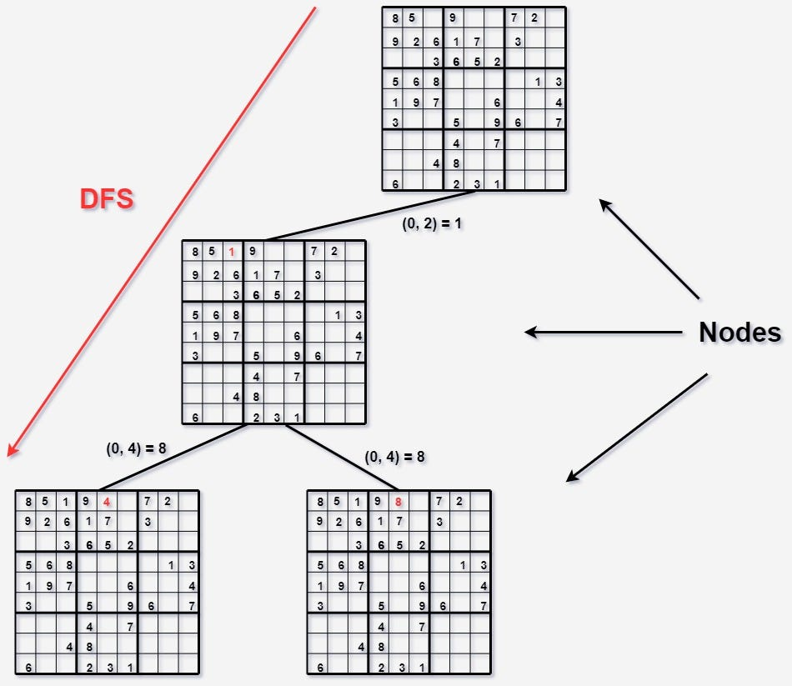

**Conclusion**

CSPs offer a systematic way to approach complex problems by framing them in terms of constraints. The backtracking technique allows us to explore possible assignments efficiently, making it a valuable tool for solving problems like Sudoku and many others.